# Abstract

In recent years, face recognition technology has been used in several applications, including in attendance tracking. The project presents the design and implementation of a student management and attendance system using face recognition technology. The system aims to automate the process of tracking student attendance and managing student information, providing a more efficient and secure solution compared to traditional methods. The system captures images of students faces as they enter the classroom, matches them against a database of registered students, and records their attendance. It also includes a GUI that allows administrators to access and manage student information, including attendance records and academic progress. The use of face recognition technology ensures that attendance records are accurate and tamper-proof. Overall, the proposed system offers a promising solution for schools, colleges, and universities looking to improve their student management and attendance tracking processes.

# Introduction

## Overview

The student management and attendance system is a software application that uses face recognition technology to automate the process of tracking student attendance and managing student information. The system is designed to work in real-world classroom settings, and uses cameras and image-processing algorithms to capture images of students' faces as they enter the classroom. The system then uses a matching algorithm to compare the captured images against a database of registered students, and records attendance for students who are successfully matched.

The system also includes a GUI that provides teachers and administrators with access to student information, including attendance records. The interface is user-friendly and easy to navigate, and allows teachers and administrators to view and manage student information in real-time.

The system is designed to provide a more efficient and secure way of tracking student attendance compared to traditional methods such as paper sign-in sheets or manual roll calls. The use of face recognition technology ensures that attendance records are accurate and tamper-proof, which makes it an ideal solution for schools, colleges, and universities.

The system has been designed and implemented using various technologies like Face detection and recognition models, Object detection, Machine Learning, GUI and Databases. This system once implemented and tested can be a great help for the institutions in order to keep the records of attendance, managing students' data, monitoring the academic progress of the students, and simplifying the process of attendance for both teachers and students.

## Problem Definition

The current method of tracking student attendance in most schools, colleges, and universities relies on traditional methods such as paper sign-in sheets or manual roll calls. These methods can be time-consuming, prone to errors, and may be vulnerable to tampering. In addition, many institutions have a hard time to monitor and manage student information, and also keeping the record of attendance, which becomes a complicated task.

The problem that this project aims to address is to provide an efficient and secure way of tracking student attendance and managing student information. By using face recognition technology, the system will be able to capture images of students faces as they enter the classroom, match them against a database of registered students, and record attendance in real-time. The system will provide a comprehensive set of tools for managing student information, which includes attendance records and also provide an easy access to students records for the teachers and administrators.

This system will help institutions to tackle the inefficiency, errors, and security issues of traditional attendance tracking methods. It will also help in the proper management of students data and monitoring of their academic progress, thus making it easy for the institutions to maintain accurate records and have a better understanding of their student's performance.

# Hardware and Software Requirements

## Hardware Requirements

* Camera: A high resolution camera at least of 12mp/720p.
* Processor: i3 processor or above is recommended.
* Memory: A minimum of 8GB of RAM is recommended.
* Storage: A minimum of 512GB of SSD storage is recommended.
* Display: The system will require a display to view the captured images and real-time student attendance and students data.

## Software Requirements

* Operating System: Windows 7 or above.
* Face recognition technology: OpenCV.
* Graphical User Interface: Python tkinter.
* Database: MySQL or PostgreSQL.

# Module Description

Login Page: It allows users to type a user name and password to log in.

Sign Up Page: The signup page (also known as a registration page) enables users and independently register and gain access to your system.

Home Page: The home page consists of many options such as student details, face recognition, attendance, help, train data, photos, developer, exit.

Student Details: This allows the admin or the user to enter user details and save it to the database.

Train Data: The photo sample which is taken is trained using a classifier.

Face Recognition: This allows users to detect the face and it will show all the details of the student.

Attendance: It shows the attendance details (present or absent). It can be also exported to a .csv file.

Photos: It shows all the photo samples taken.

Developer: It shows the details of the developer.

Help: It shows the working documentation of the application.

# Architecture Diagram

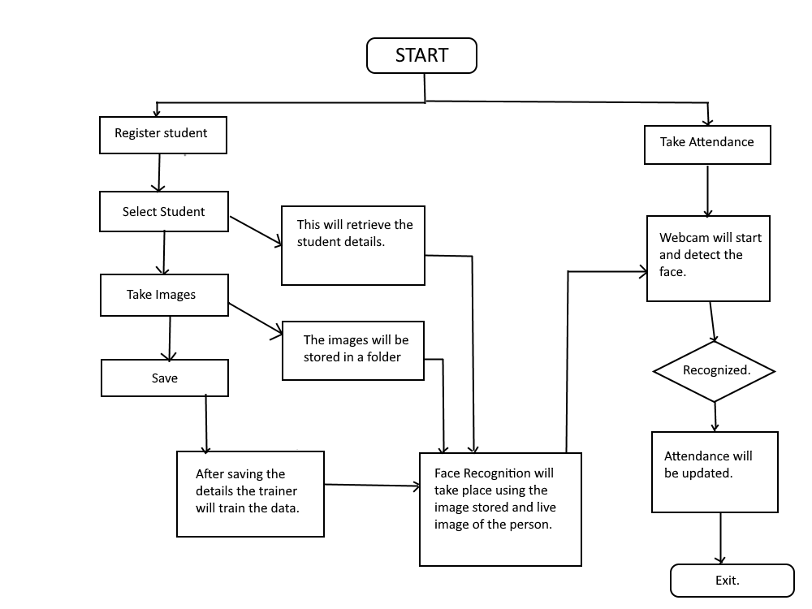

# Design Diagrams

**6.1. Use Case Diagram**

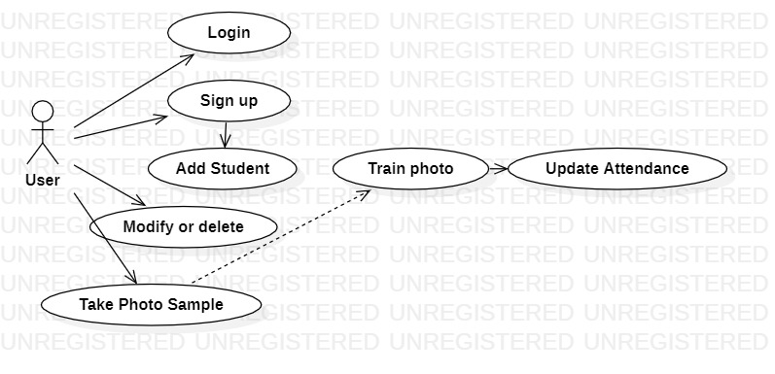

**6.2. Activity Diagram**

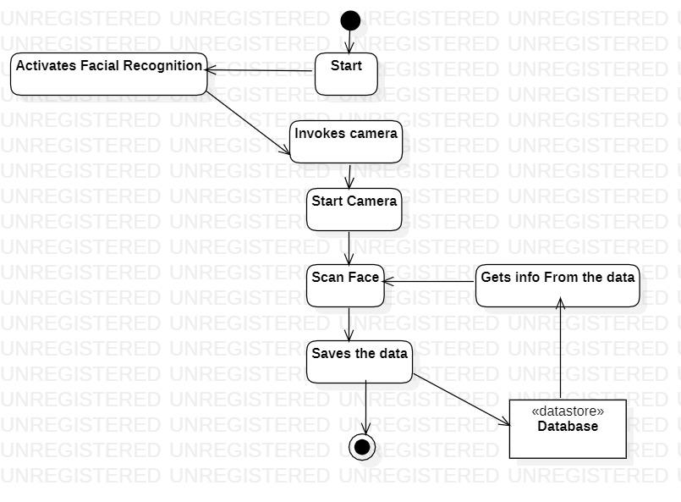

# Implementation

1. Define the system requirements: Clearly identify the features and functionalities that the student management and attendance system will need to have in order to meet the needs of the users.
2. Design the database: Create a database schema that will store student information, class schedules, and other relevant data.
3. Develop the user interface: Create a user-friendly interface that allows users to navigate the system easily.
4. Implement the core functionality: Write the code that implements the core functionalities of the system such as student registration, attendance marking, etc.
5. Collect dataset of student faces: This can be done by taking photos of students and storing them in a database.
6. Train a face recognition model: Use the collected dataset of student faces to train a face recognition model using machine learning techniques.
7. Integrate the model into the system: Use the trained model to integrate face recognition functionality into the student management and attendance system.
8. Attendance Marking : Deploy the system in the classroom setting and use it to capture images of students as they enter the room. The system will then use the face recognition model to identify each student and mark their attendance accordingly.
9. Data management: The attendance data will be stored in a database for future reference and analysis.
10. Access Control: Use the trained model to restrict access to certain areas of the school or college based on student identity.
11. Reporting: Generate reports on attendance and class participation for teachers and administrators.
12. Security: Ensure that the system is secure and that student data is protected against unauthorized access.